**Osama Akhlaq (213452)**

**Advanced Programming Ass#01**

**PhpBB**

phpBB is one of the most popular and extensively used open source software. Basically it is a flat-forum bulletin board software with a lot of extensions and styles. It is very easy to customize this software according to the needs of the user. In terms of support phpBB enjoys one of the biggest online community as compared to other bulletin softwares.

**Configuration:-**

In order to configure phpBB on any device,first we need to setup any local server. So I installed xamp on my system.Then go to the web browser and write localhost/forums,it will open the installation menu with detailed further steps.

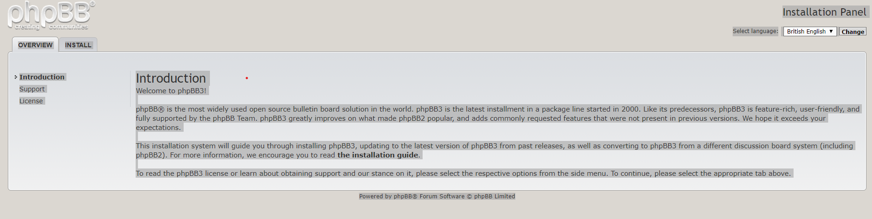

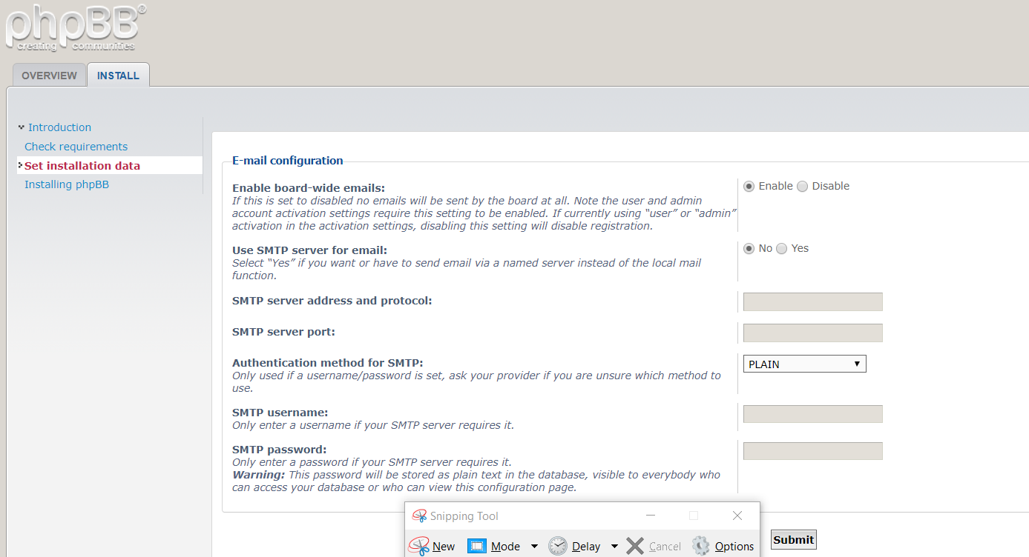

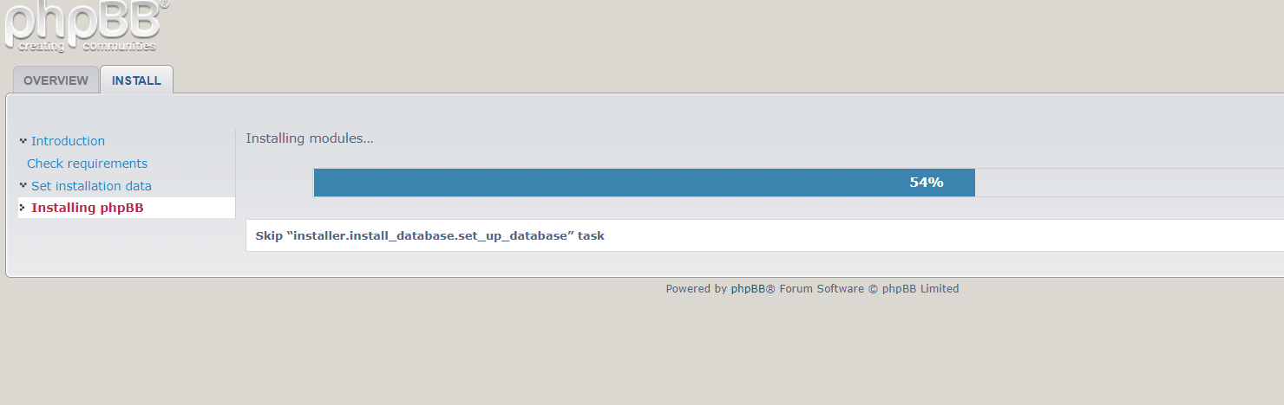

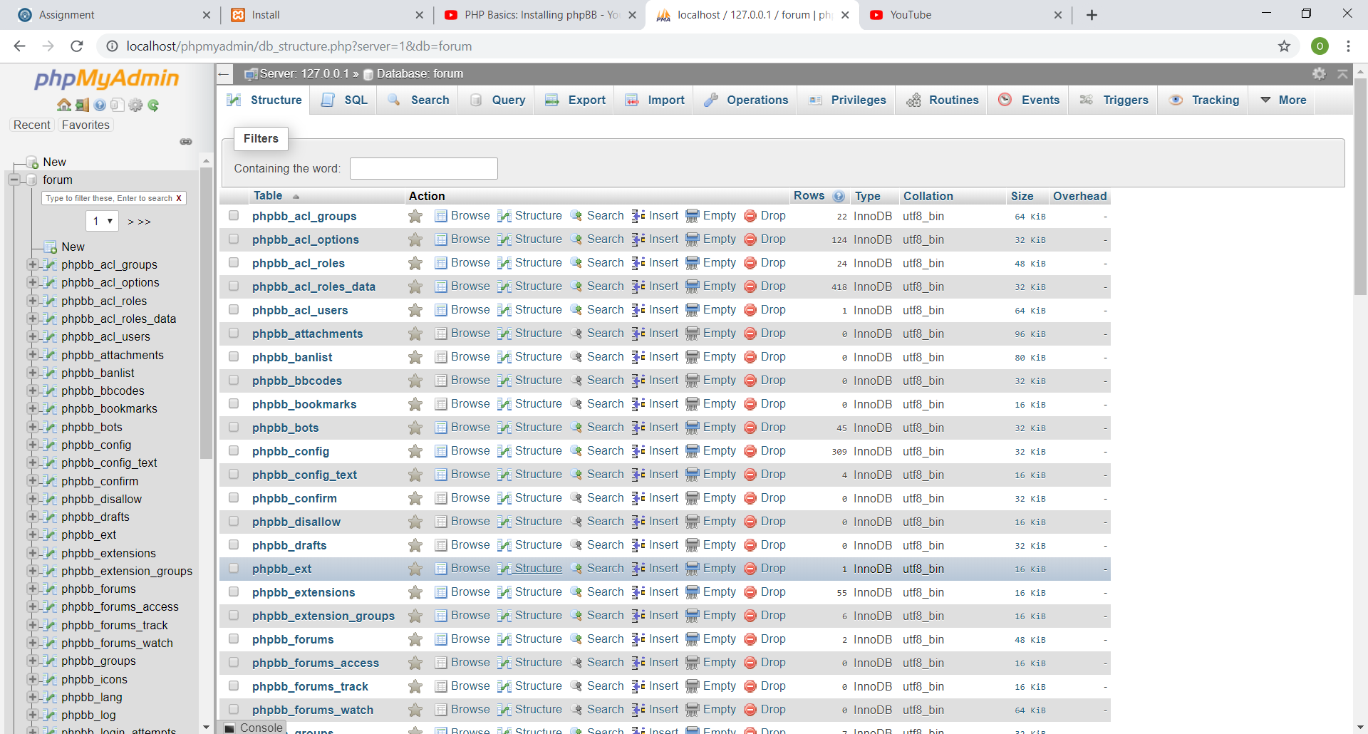

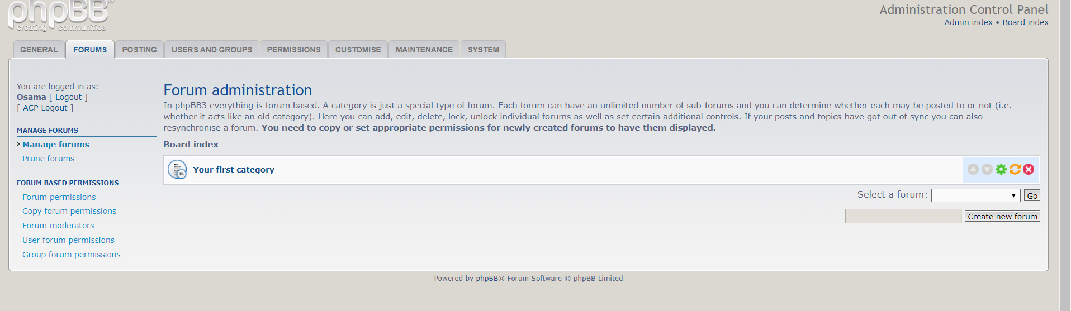

**Exploring with user perspective:-**

Phpbb provides a very user friendly interface. On the top menu bar we have varoious buttons like ‘General’,’forums’ etc which are used to control various settings like creating new forums, adding new features and blocking or adding users. The pictorial description of each button is given as:-

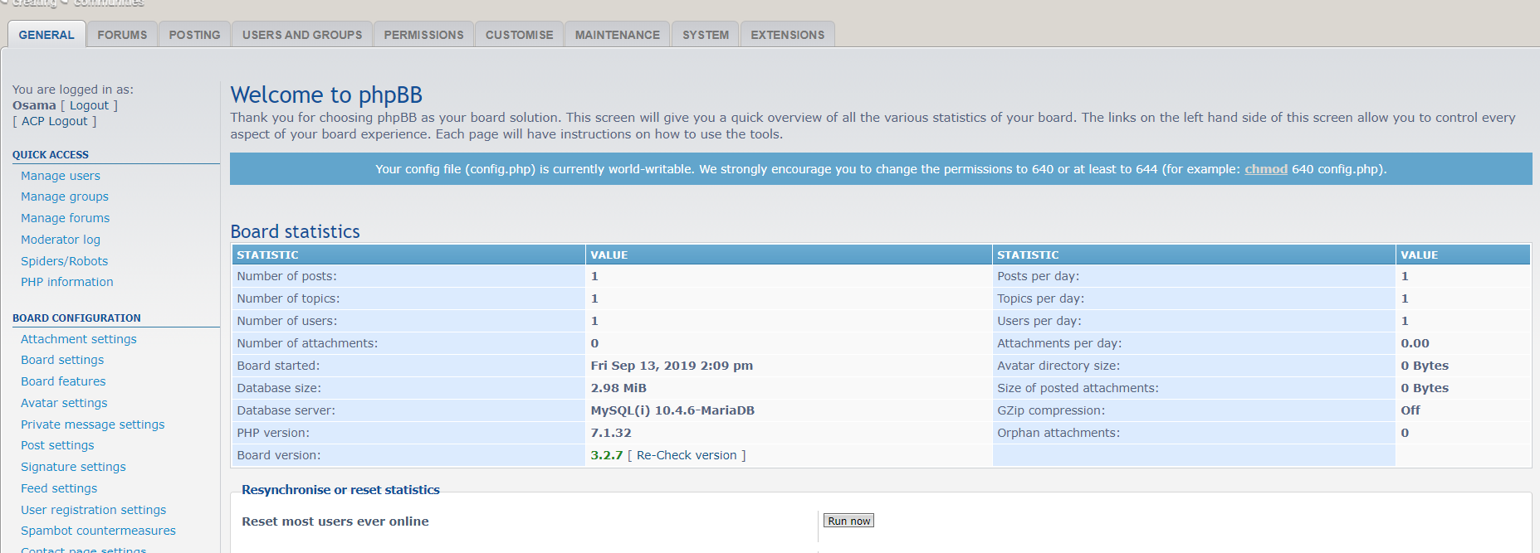

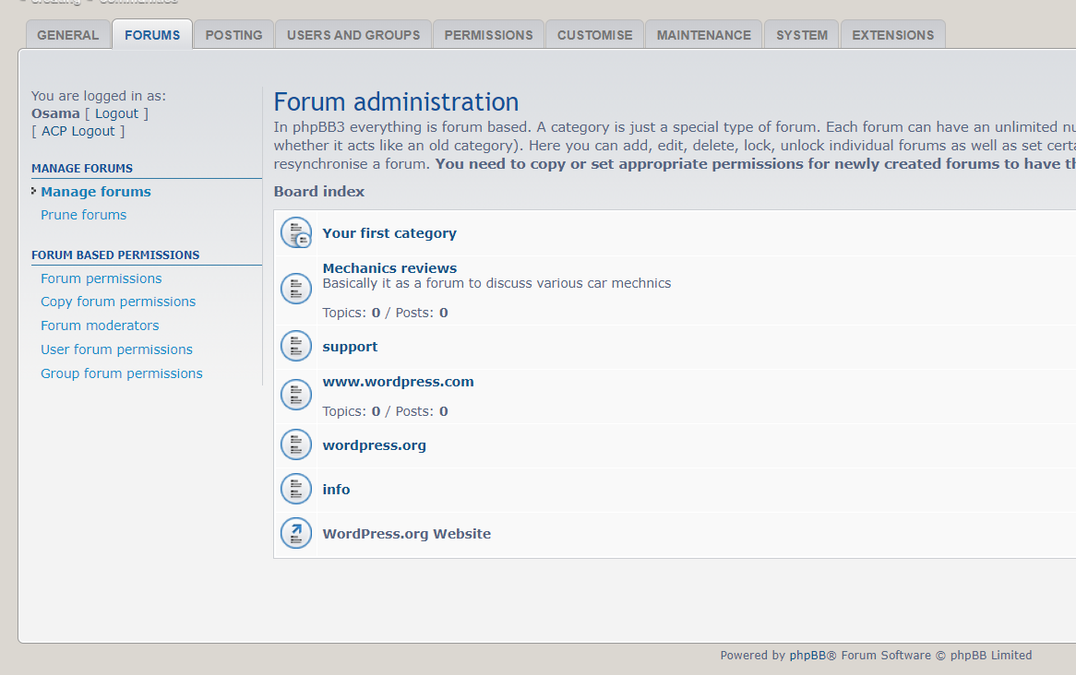

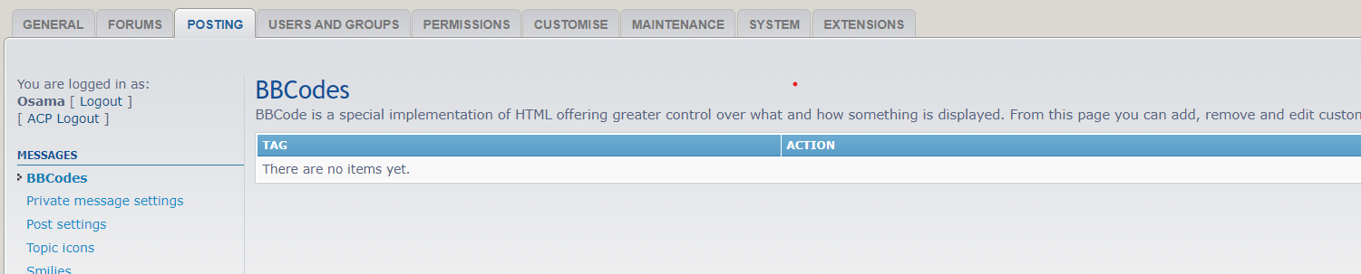

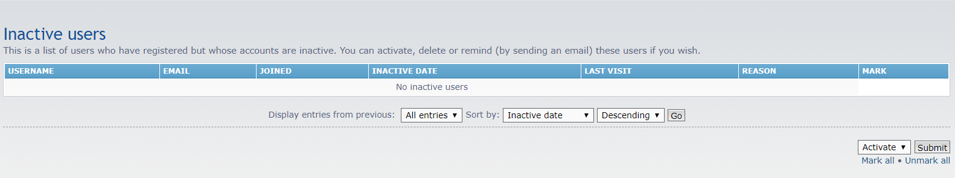

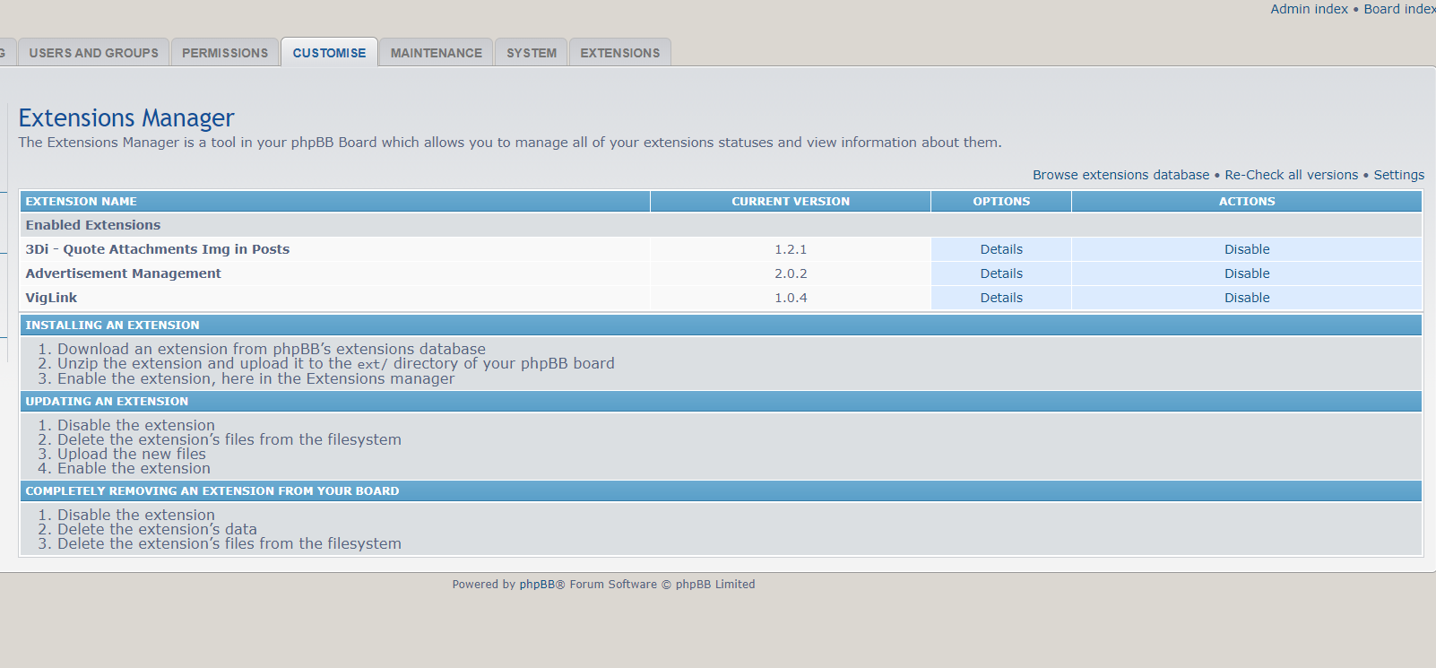

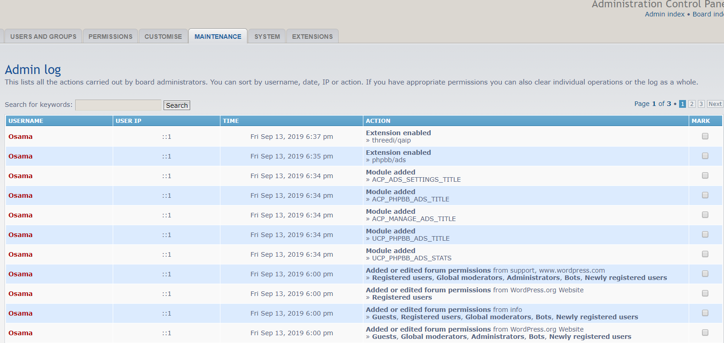

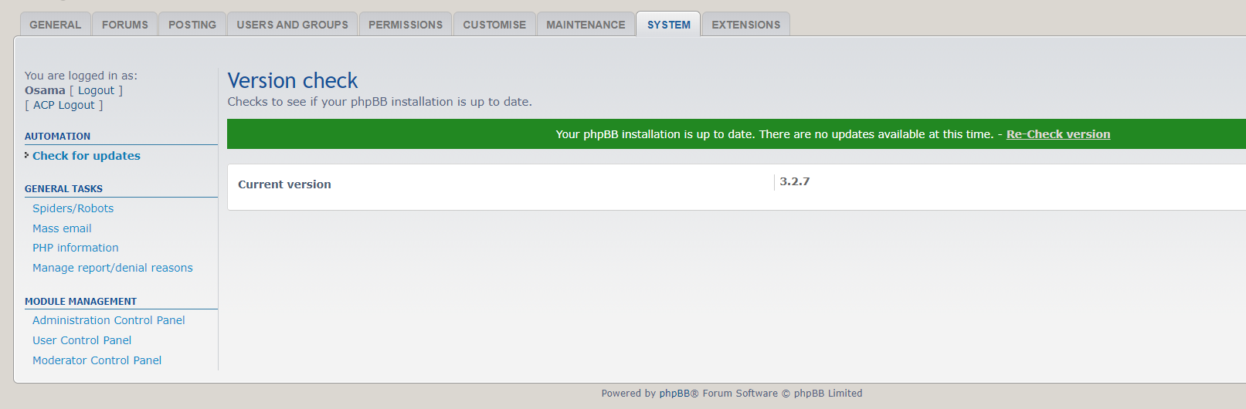

**Creating simple forums:-**







**Coding Structure:-**

Below is the list of all the folders and files which are used to run phpbb on any local/online server.

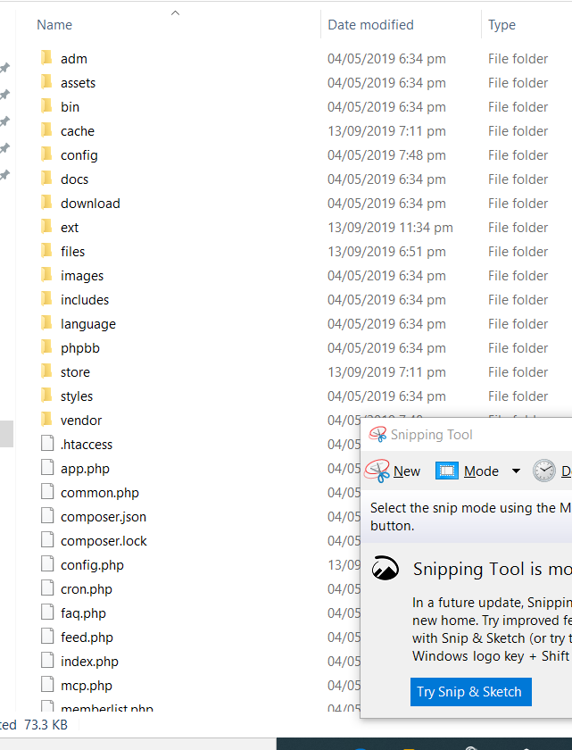

**Folders:-**

When we enter into the PhpBB folder we come across various sub-folders whose functionality is illustrated as under:-

**Adm**: this folder contains various images and styles and a php file to handle them

**Assests :** this folder contains several cookies,css styles fonts and a little bit javascript

**Bin:** this folder contains only on php file which has stored commands for PhpBB

**Cache:** this folder contains installer and production packages.

**Config:** Without this folder the board is not useable. It contains some of the hidden files for smooth running of PhpBB.

**Docs**: It is the documentation for the software.It can be done manually also. Can be used to update board.

**Download:** it conatins the downloaded material by the OSS.

**Ext:** This folder is used for extensions and plugins.

**Files:** It conatins the attachments.

**Images:** Contains various images like smileys,icons etc.

**Includes:** It conatins the imported libraries.

**Languages:** phpBB supports various languages on its board.

**Phpbb :** this folder contains files that helps user to put on the server.

**Store:** this folder is used for backup purpose.

**Styles:** It includes all the styles and the latest downloaded styles as well.

**Vendor:** It contains the information about the version. Whenever the OSS is updated this folder is modified.

**Files:**

There are also some of the files in the phpBB folder whose functionality is as under:-

**.htaaccess:** this file contains the security information about the forum.

**App.php:** It contains the interface for our extensions.

**Common.php:** urls for home and serveral other files are stored in this file.

**Compressoe.json:** It conatins various schemas.

**Compressor.lock:** This file locks the dependencies of a project to a known state.

**Config.php:** it establishes php connection.

**Cron.php:** it contains all the information about the user activity on the board.

**Faq.php:** contains the information about the frequently asked questions.

**Feed.php**: It includes the IP addresses of the users who have been logged into the site.

**Index.php:** It is the structure for the whole website.It is a mixture of different codes delivered as a php code.

**Mcp.php:** It is the modern control panel page of phpBB.

**Search.php:** it stores the search results.

**Database Structure:-**

As far as database is concerned we have the following tables stored in the local host server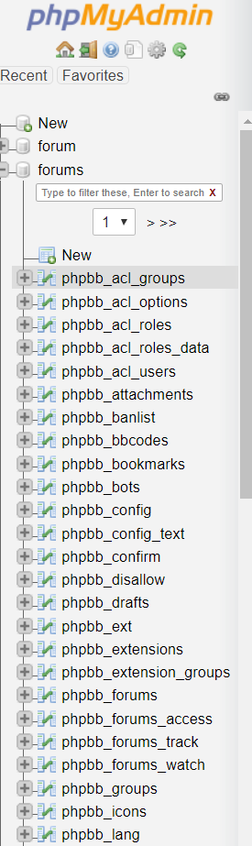

Pictorial description of some of these tables are as under:-

**Phpbb_acl_groups:-**

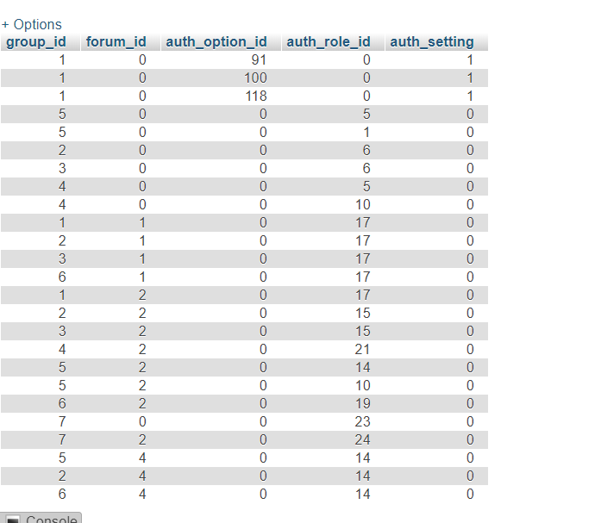

**Phpbb_acl_options:-**

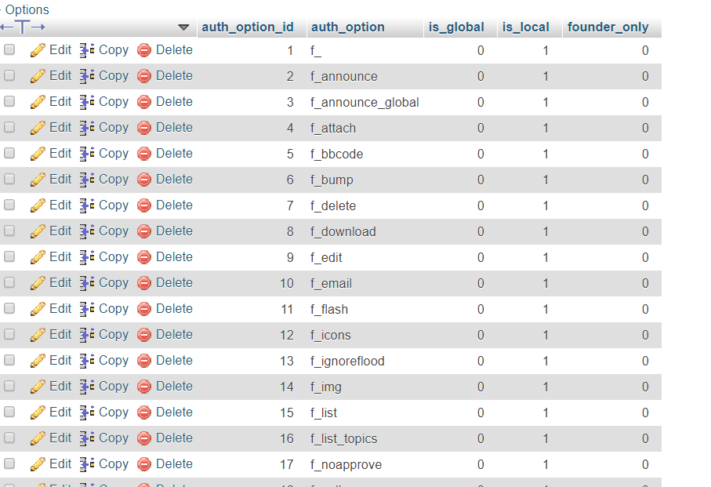

**Phpbb_acl_roles:-**

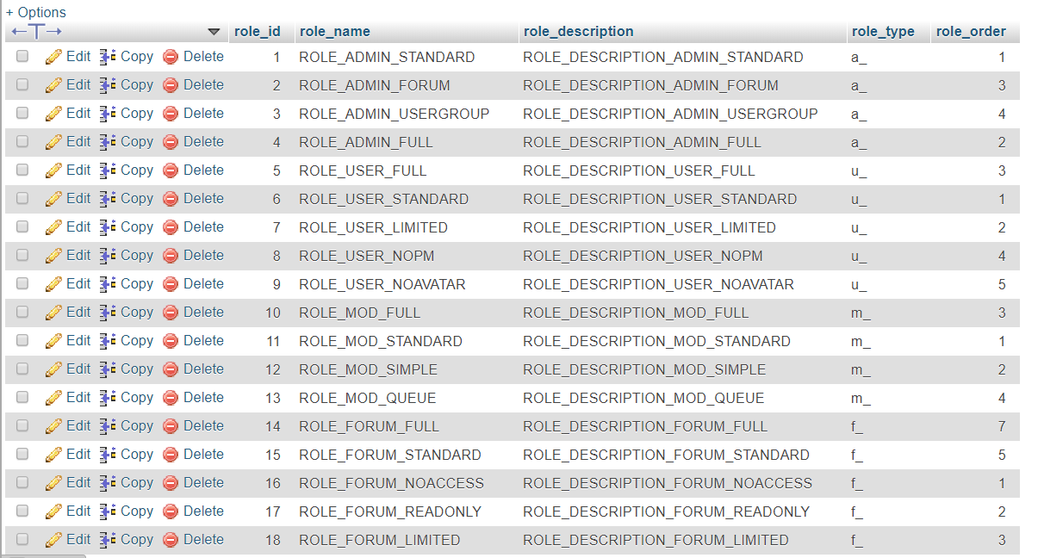

**Phpbb_acl_roles_data:-**

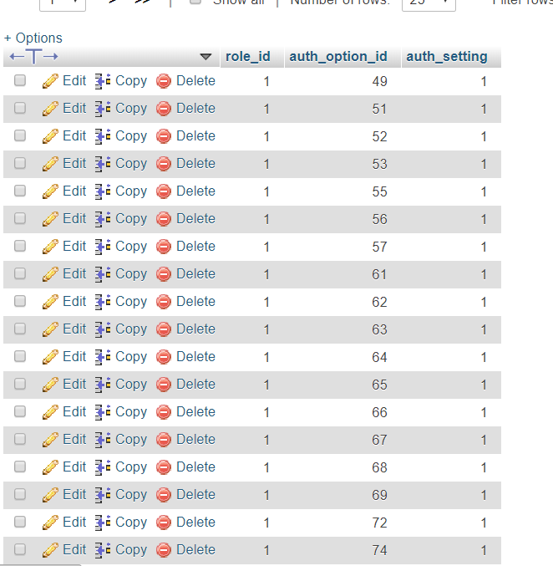

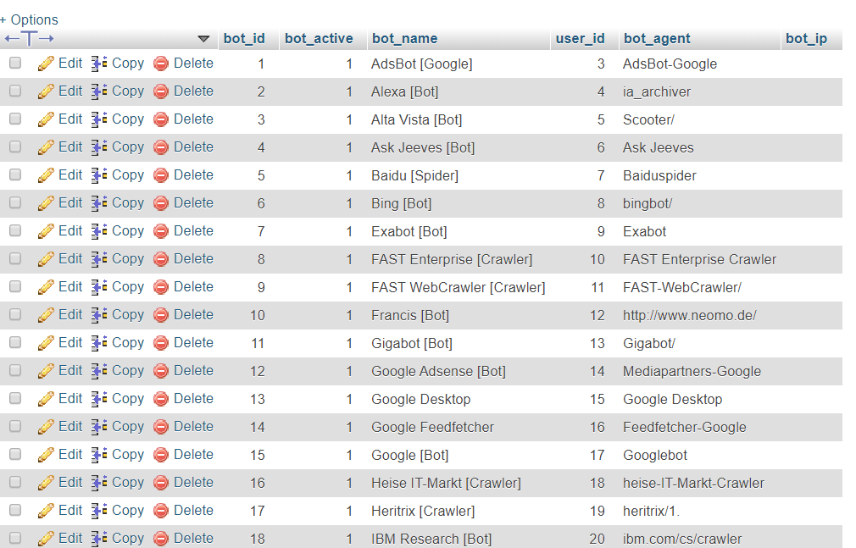

**Phpbb_config:-**

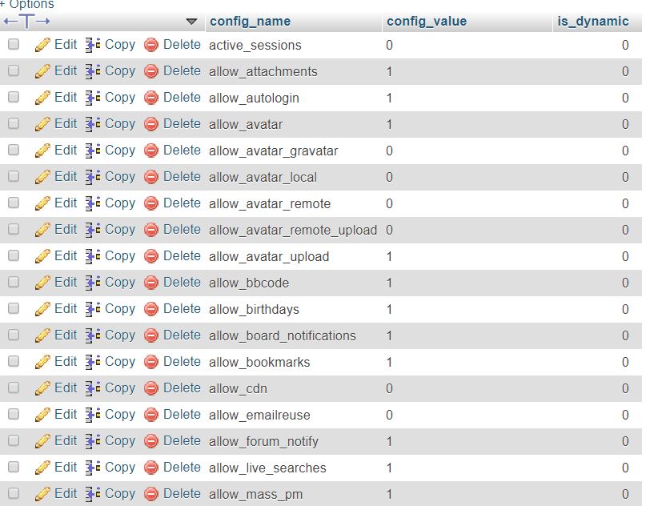

**Phpbb_extensions:-**

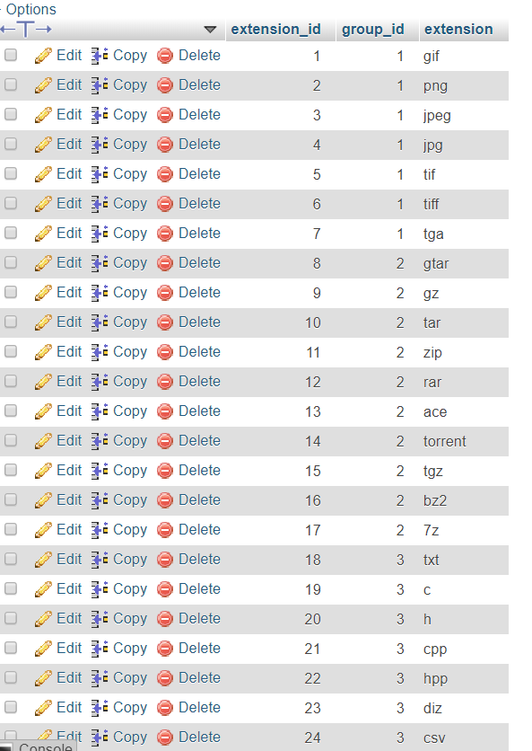

**Phpbb_migrations:-**

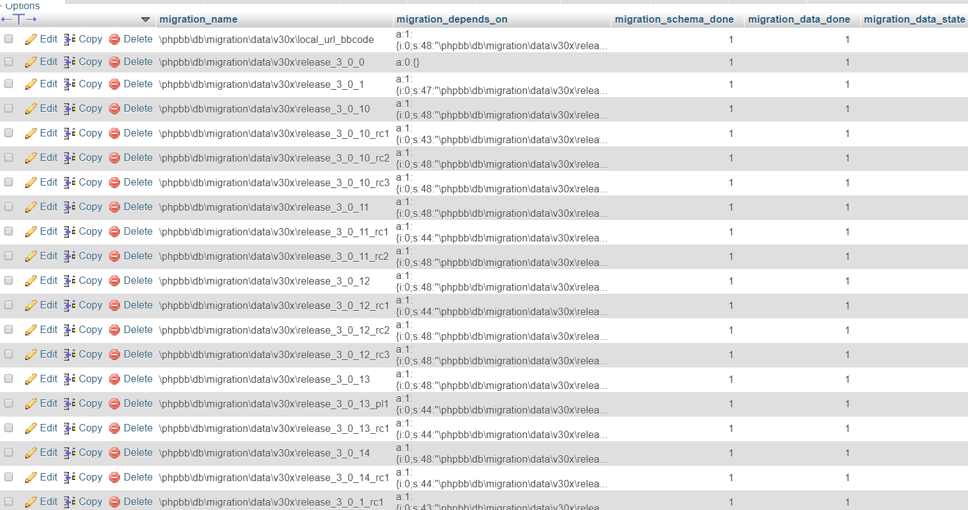

**Phpbb_modules:-**

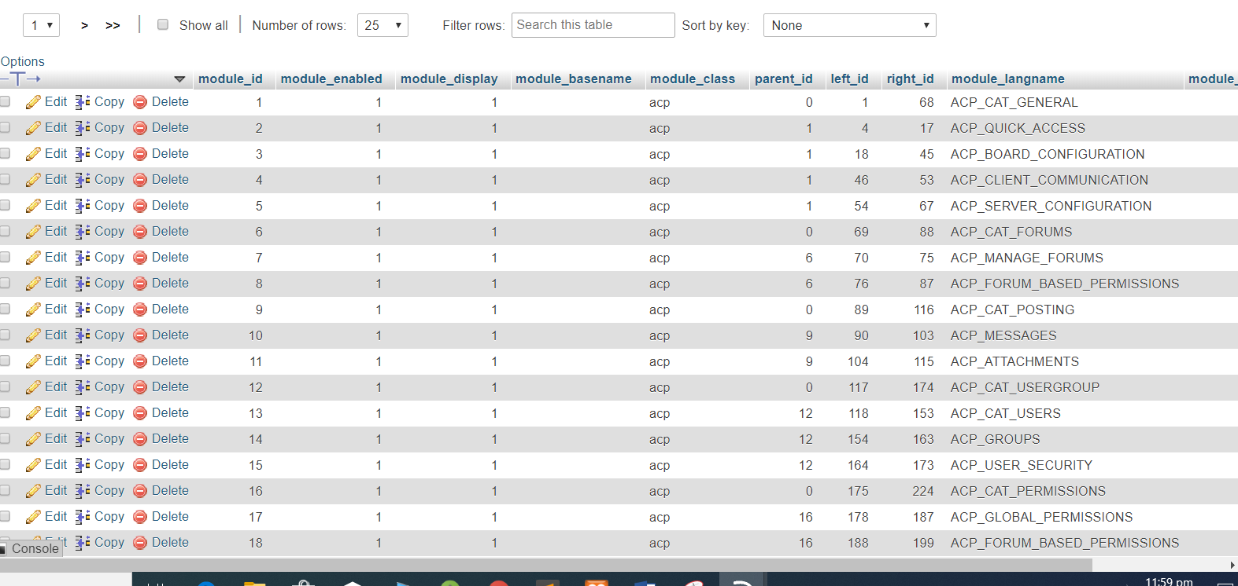

**Phpbb_notification_types:-**

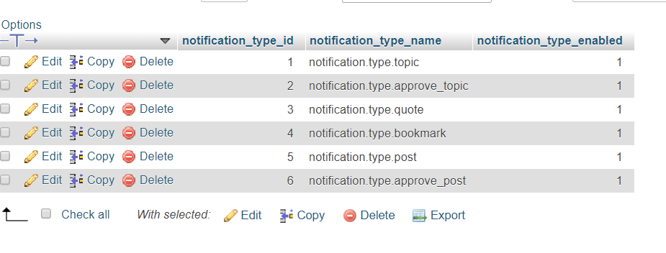

**Phpbb_posts:-**

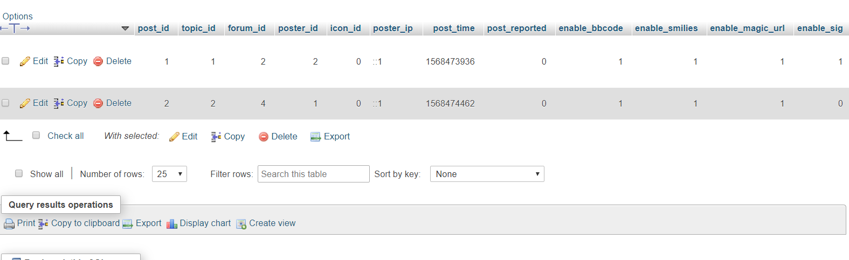

**Phpbb_reports_reasons:-**

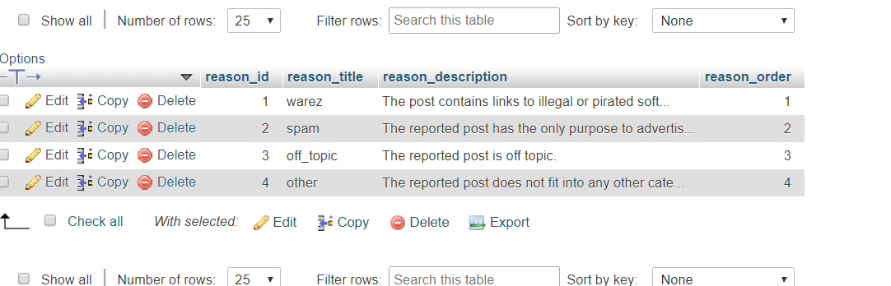

**Adding Plugins:-**

Adding a plugin is very easy in phpbb as compared to other open source softwares. All we have to do is to download a plugin of our own choice. Then we have to place that plugin in the ext folder placed inside the phpbb folder. Finally one has to go to the customize section of the phpbb in order to enable that extension.

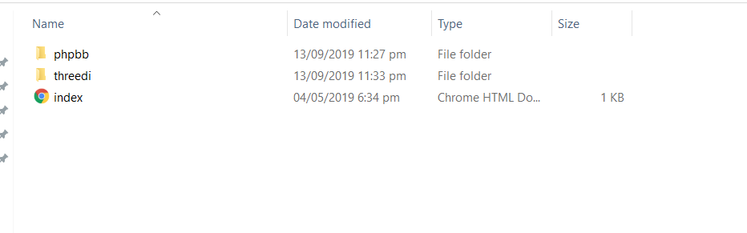

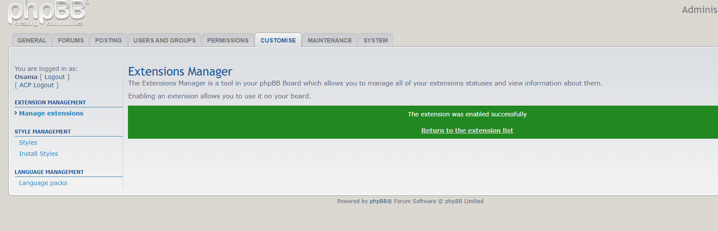

Similarly adding a style is also very easy. Simply download a theme which you consider most suitable and place it in the styles folder.Then go to the customize folder in order to install it and hence it is done.

